Frequency Modulation (FM)

- Basic Principles of Frequency Modulation (FM)

Frequency Modulation (FM) is a modulation technique in which the frequency of the carrier wave is varied according to the amplitude of the input (message) signal, while the amplitude of the carrier remains constant. FM is widely used in radio broadcasting, television sound transmission, and wireless communication systems because of its high resistance to noise and interference.
In Frequency Modulation, when the amplitude of the message signal increases, the carrier frequency increases above its normal value. Similarly, when the message signal decreases, the carrier frequency decreases below its normal value. The amount of frequency change is known as the frequency deviation and is directly proportional to the amplitude of the modulating signal.
The main components of an FM system are:
Message Signal (Information Signal).
Carrier Signal.
FM Modulator.
FM Demodulator.
Key Characteristics of FM
Constant carrier amplitude.
Frequency varies according to the message signal.
Better noise immunity than AM.
Higher bandwidth requirement.
Improved sound quality in broadcasting applications.
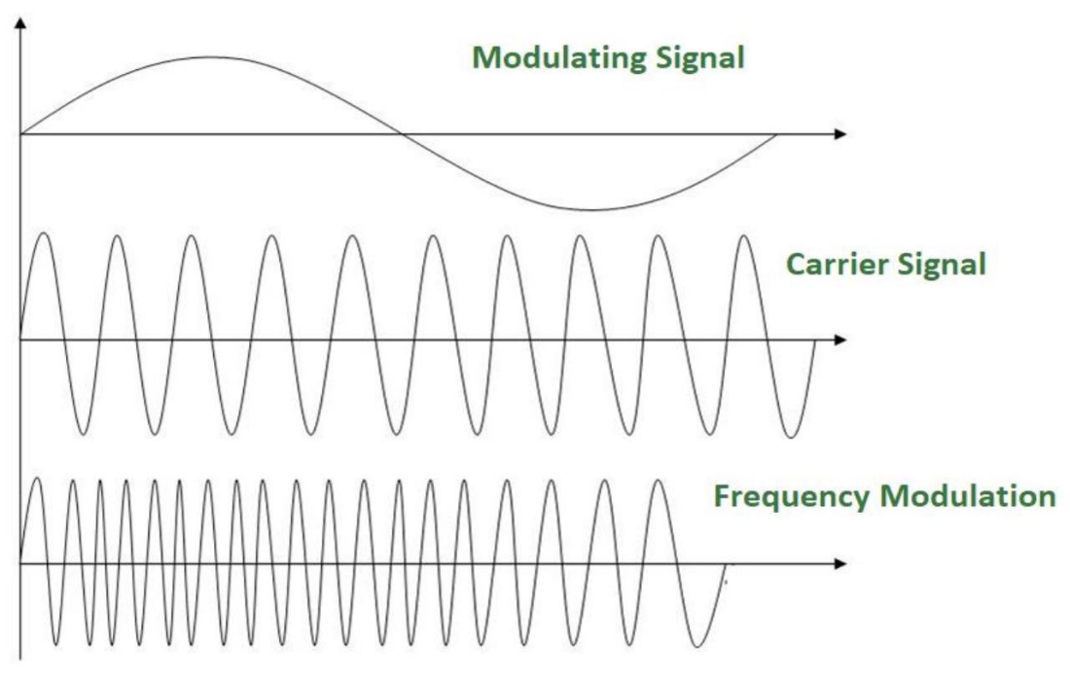

Modulation-index:

- Definition: The Modulation Index (β) is a dimensionless ratio that measures how deeply a carrier wave is modulated by the message signal.
Mathematical Formula:
$$β=⍙f\backslash fm$$

⍙f (Peak Frequency Deviation): The maximum shift away from the center carrier frequency (measured in Hz).
fm (Modulating Frequency): The frequency of the baseband audio/data signal (measured in Hz).
Key Points:
No Upper Limit: Unlike AM, the FM modulation index can be much greater than 1 without causing any signal distortion.
Determines Bandwidth: The value of \beta dictates how many sidebands are created and how much bandwidth (B) the signal occupies via Carson's Rule:

$$B=2fm\left(β+1\right)$$
System Types:
If β is small (β ≤ 1): It is Narrowband FM (conserves bandwidth).
If β is large (β ≥ 1): It is Wideband FM (high noise immunity and superior audio quality).

Common Applications of Frequency Modulation (FM)

